**Enhancing Security Operations: SIEM Qradar & SOC Dashboard Management**

Enhancing Security Operations: SIEM Qradar & SOC Dashboard Management "SIEM Implementation: The project team will deploy and configure the IBM Qradar SIEM solution, integrating it with the organization's existing network infrastructure, security devices, and data sources. This will enable centralized log collection, real-time event correlation, threat detection, and incident response capabilities.Dashboard Customization: The SOC dashboard will be designed and tailored to provide a comprehensive and intuitive view of the organization's security posture.

The project team will collaborate with SOC analysts to identify key performance indicators (KPIs), relevant metrics, and visualizations that will empower analysts to effectively monitor, detect, and respond to security incidents. Threat Intelligence Integration: The SIEM system will be integrated with external threat intelligence feeds and vulnerability databases to enrich the analysis and detection capabilities. This integration will provide real-time information on emerging threats, known attack vectors, and potential vulnerabilities, empowering the SOC team to proactively respond to emerging risks.

**Technical Architecture**

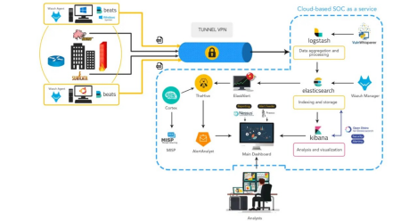

**1.** **Overview**

**This evaluation's domain was restricted to offline testing of the VM image delivered by the "PARTY". Vulnerabilities found in the virtual machine image during VAPT are listed in the assessment report. The audit of the application took place from Nov 16th to Nov 23rd. The purpose of the audit was to identify the potential vulnerabilities in the web application. The vulnerabilities tested in the web application included Unauthorized access, Configuration Management issues, Information leakages etc..,. Black box testing was performed.**

**Test was limited only to web applications and does not include host server or network related issues.**

**Database security design is also not in scope.**

**The security review revealed Default credentials are used in the admin page, Captcha is not implemented in the admin page, SSL Encryption not enabled, Full path Disclosure, Sensitive Information Exposure. The following are the brief description of findings in the application**

**Apart from our standard security assessment practices, we performed general review of applications and the same is provided in our reporting format. Below gives the glance of complete sections of our security assessment, where for this report we are highlighting the findings as below.**

**The details of the estimated levels are given in full text. Below is a brief list of threats to which the perimeter is exposed.. {2 } days of VAPT testing were conducted by a team of {3}. Assuming a VM image with the specified specifications in the document was deployed in the network. The testing environment's network image is shown below.**

**Image à internal network ->192.168.0.109 à Xbersec**

## **2.** **List of employees participated in the HUFFPOST:**

|  |  |  |  |
| --- | --- | --- | --- |
| **S. No.** | **Name** | **Designation** | **Mobile No.** |
|  |  |  |  |

**3.** **List of Vulnerable Parameter, Location discovered**

|  |  |  |  |
| --- | --- | --- | --- |
| **S. No.** | **Vulnerability Path** | **Name of The Vulnerability** | **References-CWE** |
| **1.1**    **1.2** | [**http://192.168.0.109:8080/admin/en/blog**](http://192.168.0.109:8080/admin/en/blog)  [**http://192.168.0.109:8080/admin/en/report_contact_us**](http://192.168.0.109:8080/admin/en/report_contact_us) | **Cross-Site Scripting (Stored)** | **CWE-79: Improper Neutralization of Input During Web Page Generation ('Cross-site Scripting')** |
| **2** | **http://192.168.0.100:8080/sh/admclient** | **NO session management** | **CWE-384: Session Fixation** |
| **3** | **http://192.168.0.109:8080/sh/login** | **Login captcha bypass** | **CWE-804: Guessable CAPTCHA** |
| **4** | [**http://192.168.0.109:8080/sh/login**](http://192.168.0.109:8080/sh/login) | **Admin login SQL injection** | **CWE-284: Improper Access Control** |
| **5** | [**http://192.168.0.109:8080/admin/en/vulnerability**](http://192.168.0.109:8080/admin/en/vulnerability) | **Broken Access Control** | **CWE-284: Improper Access Control** |
| **6** | **http://192.168.0.109:8080/manager/html** | **Default credentials** | **CWE-1392: Use of Default Credentials** |
| **7.1**      **7.2**      **7.3** | **[http://192.168.0.109:8080/tl/vulnerability](http://192.168.0.109:8080/tl/vulnerability%0b%20%20http:/192.168.0.109:8080/uploads/shell.jsp?cmd=ls)**  **[http://192.168.0.109:8080/uploads/shell.jsp?cmd=ls](http://192.168.0.109:8080/tl/vulnerability%0b%20%20http:/192.168.0.109:8080/uploads/shell.jsp?cmd=ls)**    [**http://192.168.0.109:8080/admin/en/profile_settings**](http://192.168.0.109:8080/admin/en/profile_settings) | **File upload** | **CWE-434: Unrestricted Upload of File with Dangerous Type** |
| **8** | [**http://192.168.0.109:8080/**](http://192.168.0.109:8080/) | **Anti-CSRF Token missing** | **CWE-352: Cross-Site Request Forgery (CSRF)** |
| **9** | [**http://192.168.0.109:8080/manager**](http://192.168.0.109:8080/manager/html) | **Apache Tomcat Enabled** | **CWE-284: Improper Access Control** |
| **10** | [**http://192.168.0.109:8080**](http://192.168.0.109:8080/)**/** | **System Information Exposure** | **CWE-497: Exposure of Sensitive System Information to an Unauthorized Control Sphere** |
| **11** | [**http://192.168.0.109:8080/**](http://192.168.0.109:8080/) | **Secure Http flag** | |  |  | | --- | --- | |  |  | | **CWE-497: Exposure of Sensitive System Information to an Unauthorized Control Sphere** | |
| **12** | [**http://192.168.0.109:8080/**](http://192.168.0.109:8080/) | **SSL Encryption is not enabled** | **CWE-319: Cleartext Transmission of Sensitive Information** |
| **13** | [**http://192.168.0.109:8080/**](http://192.168.0.109:8080/) | **Local file Inclusion** | **CWE-98: Improper Control of Filename for Include/Require Statement in PHP Program ('PHP Remote File Inclusion')** |
| **14.1**      **14.2** | [**http://192.168.0.109:8080/**](http://192.168.0.109:8080/)      [**http://192.168.0.109:8080/admin/en/blog**](http://192.168.0.109:8080/admin/en/blog) | **Cross-Site Scripting (Reflected)** | |  |  | | --- | --- | |  |  | | **CWE-79: Improper Neutralization of Input During Web Page Generation ('Cross-site Scripting')** | |
| **15.1**    **15.2** | [**http://192.168.68.59:8080/admin/en/profile**](http://192.168.68.59:8080/admin/en/profile)    [**http://192.168.68.59:8080/**](http://192.168.68.59:8080/) | **Insecure Design** | **CWE-657: Violation Of Secure Design Principle**    **CWE-1021:Improper UI Layers** |
| **16** | [**http://192.168.0.109:8080/admin/en/blog**](http://192.168.0.109:8080/admin/en/blog) | **Software And Data Integrity Failures** | **CWE-784:Validation Integrity Checking In Security Design** |
| **17** | [**http://192.168.68.59:8080/admin/en/blog**](http://192.168.68.59:8080/admin/en/blog) | **Security Loggings And Monitoring Failures** | **CWE-1004: Sensitive cookie with HTTP** |
| **18** | [**http://192.168.68.59:8080/manager.hml**](http://192.168.68.59:8080/manager.hml) | **Server-Side Request Forgery** | **CWE-200: Sensitive Information To Unauthorized Actors** |

## **4.** **Other Information**

**· Tool: BurpSuite Pro, Sqlmap, Nmap, Browser Ad-ons**

**· Employee Details:**

**1— 1.1 . Vulnerability Name**: Cross-Site Scripting (Stored)

**CWE** : CWE-79

**OWASP Category**: A03:2021 – Injection

**Description**: Untrusted data enters a web application, typically from a web request

**Business Impact**: The application stores dangerous data in a database, message forum, visitor log, or other trusted data store. At a later time, the dangerous data is subsequently read back into the application and included in dynamic content. From an attacker's perspective, the optimal place to inject malicious content is in an area that is displayed to either many users or particularly interesting users. Interesting users typically have elevated privileges in the application or interact with sensitive data that is valuable to the attacker. If one of these users executes malicious content, the attacker may be able to perform privileged operations on behalf of the user or gain access to sensitive data belonging to the user. For example, the attacker might inject XSS into a log message, which might not be handled properly when an administrator views the logs.

**Vulnerability Path** :<http://192.168.0.109:8080/>

**Vulnerability Parameter**:<http://192.168.0.109:8080/admin/en/blog>

**Steps to Reproduce** :

Step 1. Access the URL

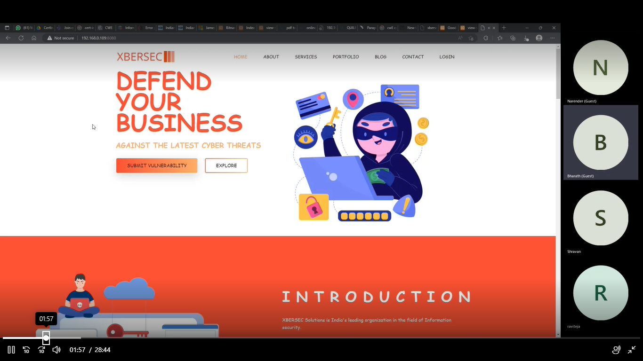

Step 2: Go to the login page and enter credentials

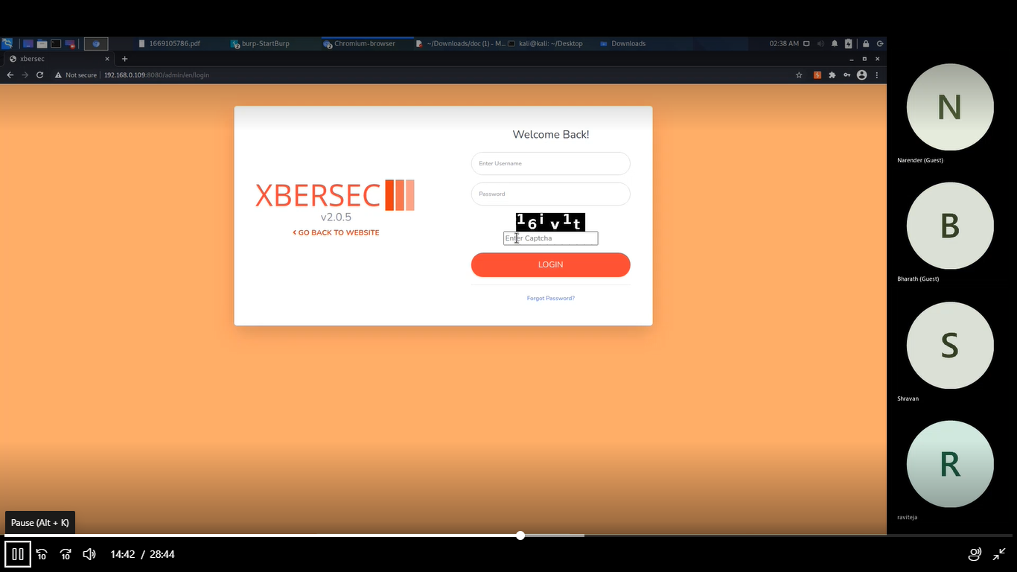

Step 3: Now you will be redirected to the dashboard where we will enter the script.

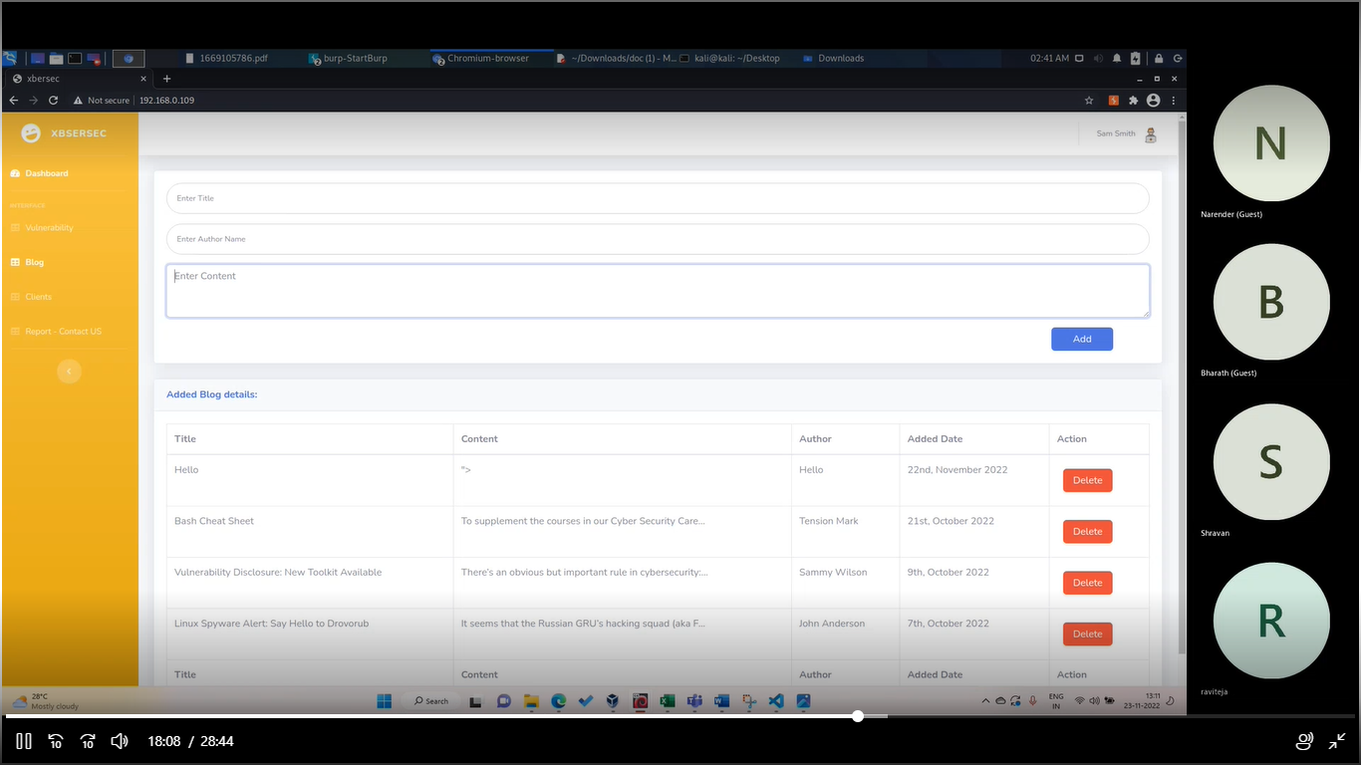

Step 3:-after entering the script content like” hacked” u will find the dialogue box as shown below.

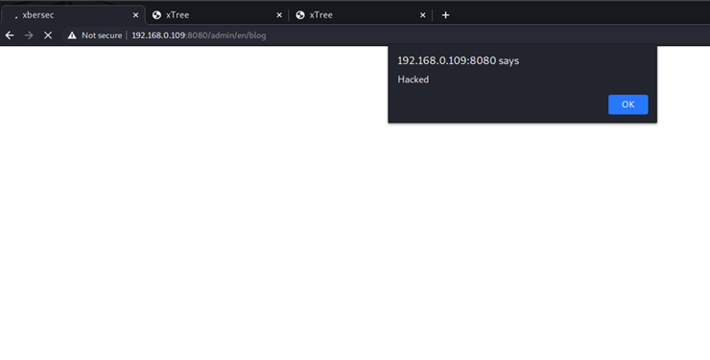

**Recommendation**:

* Note that proper output encoding, escaping, and quoting is the most effective solution for preventing XSS, although input validation may provide some defense-in-depth.

**1— 1.2 . Vulnerability Name**: Cross-Site Scripting (Stored)

**CWE** : CWE-79

**OWASP Category**: A03:2021 – Injection

**Description**: Untrusted data enters a web application, typically from a web request

**Business Impact**: The application stores dangerous data in a database, message forum, visitor log, or other trusted data store. At a later time, the dangerous data is subsequently read back into the application and included in dynamic content. From an attacker's perspective, the optimal place to inject malicious content is in an area that is displayed to either many users or particularly interesting users. Interesting users typically have elevated privileges in the application or interact with sensitive data that is valuable to the attacker. If one of these users executes malicious content, the attacker may be able to perform privileged operations on behalf of the user or gain access to sensitive data belonging to the user. For example, the attacker might inject XSS into a log message, which might not be handled properly when an administrator views the logs.

**Vulnerability Path** :<http://192.168.0.109:8080/>

**Vulnerability Parameter**:[http://192.168.0.109:8080/](http://192.168.0.109:8080/admin/en/blog)admin/en/report_contact_us

**Steps to Reproduce** :

Step 1. Access the URL



Step 2: Go to the login page and enter credentials



Step 3: Now you will be redirected to the dashboard where we enter the script in the contact_us page.

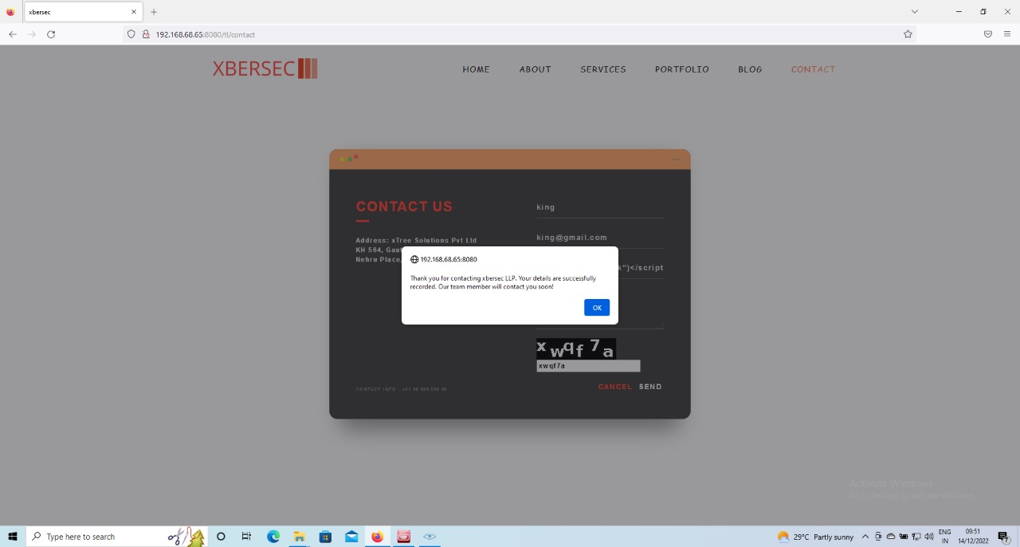

Step 4:- this is the pop up you get after you successfully inject the script in the contact page.

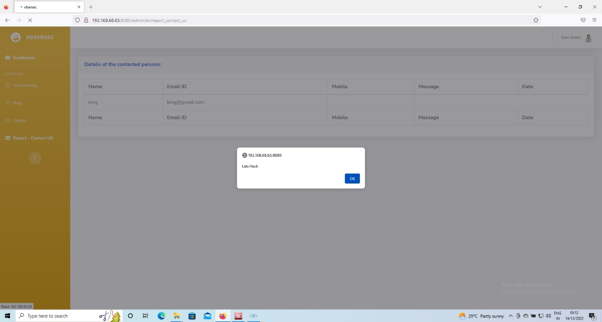

**Recommendation**:

* Note that proper output encoding, escaping, and quoting is the most effective solution for preventing XSS, although input validation may provide some defense-in-depth.

**2 .Vulnerability Name**:No Session Management

**CWE** : CWE-384

**OWASP Category**:A07:2021 –Identification and Authentication Failures

**Description**:An attacker is able to force a known session identifier on a user so that, once the user authenticates, the attacker has access to the authenticated session.

**Business Impact**:Without appropriate session management, you can run into several security problems, putting your users at risk. Common vulnerabilities caused by a lack of or poorly implemented session management include: ‌Session hijacking

**Vulnerability Path** :<http://192.168.0.109:8080/>

**Vulnerability Parameter**:<http://192.168.0.100:8080/sh/admclient>

**Steps to Reproduce** :

Step 1. Access the URL



Step 2.without the proper session management the burp can still access the request of session as shown.

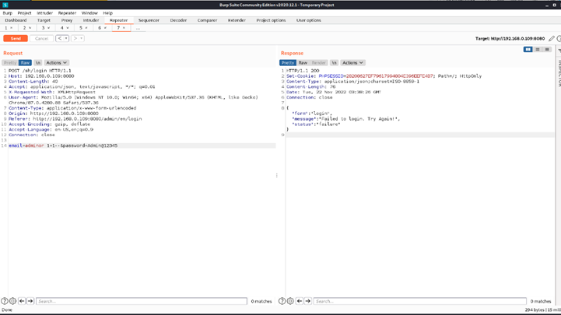

**Recommendation**:

* Invalidate any existing session identifiers prior to authorizing a new user session.

**3 . Vulnerability Name**:Login Captcha Bypass

**CWE** : CWE-804

**OWASP Category**:A06:2021-Vulnerable and Outdated Components

**Description**:An automated attacker could bypass the intended protection of the CAPTCHA challenge and perform actions at a higher frequency than humanly possible, such as launching spam attacks.

**Business Impact**:When authorization, authentication, or another protection mechanism relies on CAPTCHA entities to ensure that only human actors can access certain functionality, then an automated attacker such as a bot may access the restricted functionality by guessing the CAPTCHA.

**Vulnerability Path** :<http://192.168.0.109:8080/>

**Vulnerability Parameter**:[**http://192.168.0.109:8080/sh/login**](http://192.168.0.109:8080/sh/login)

**Steps to Reproduce** :

Step 1. Access the URL



Step :- in the backend this login page is by default giving the access without the captcha.



Step 3:- these the backend in the burp where you can see that without the captcha validation it is given the access to session.

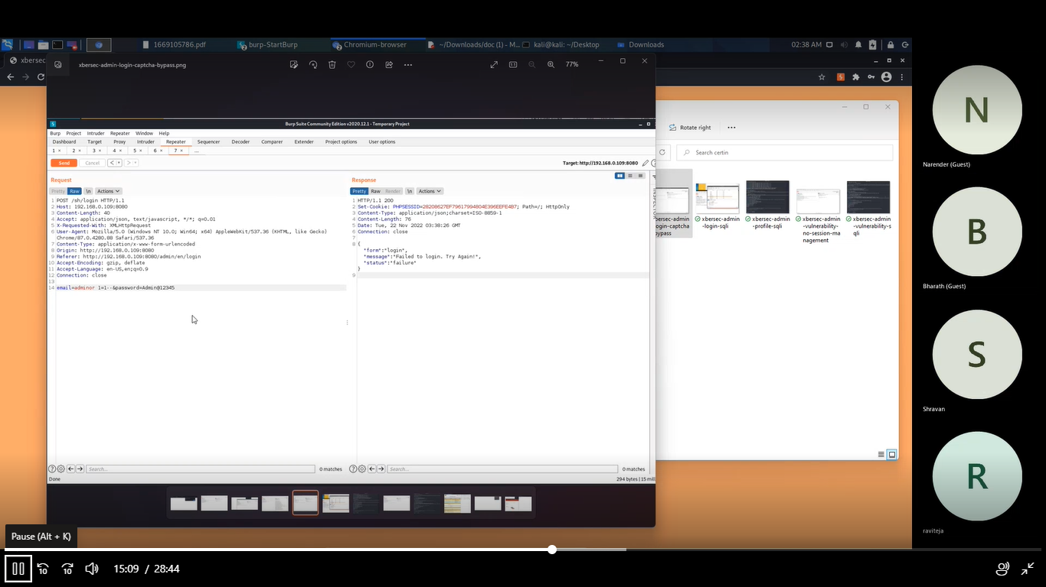

**Recommendation**:

Ensure that the CAPTCHA value stored in the session is verified against the user's input and is removed when the request is submitted.

**4 . Vulnerability Name**:Admin Login SQL Injection

**CWE** : CWE-284

**OWASP Category**:A03:2021-Injections

**Description**:Without sufficient removal or quoting of SQL syntax in user-controllable inputs, the generated SQL query can cause those inputs to be interpreted as SQL instead of ordinary user data. This can be used to alter query logic to bypass security checks, or to insert additional statements that modify the back-end database, possibly including execution of system commands.

**Business Impact**:If authorization information is held in a SQL database, it may be possible to change this information through the successful exploitation of a SQL injection vulnerability

**Vulnerability Path** :<http://192.168.0.109:8080/>

**Vulnerability Parameter**:[**http://192.168.0.109:8080/sh/login**](http://192.168.0.109:8080/sh/login)

**Steps to Reproduce** :

Step 1. Access the URL



Step 2:- Enter the login credentials in and try to validate as shown below.

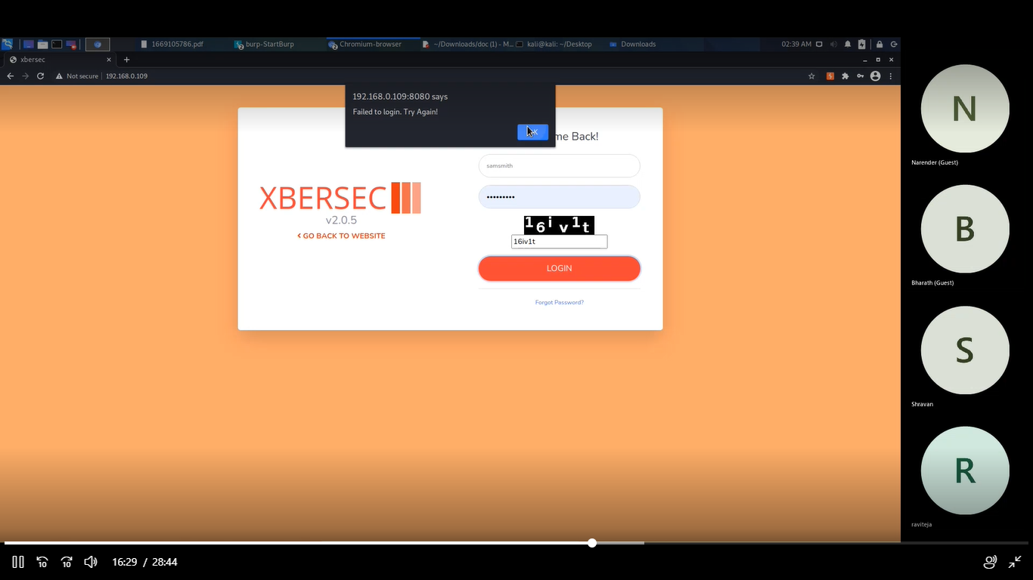

Step 3:- in the backend we need to use the burp to configure the user with sql injection.



Step 4: - this is the place where we upload injection then you will gain access to one of the user accounts.

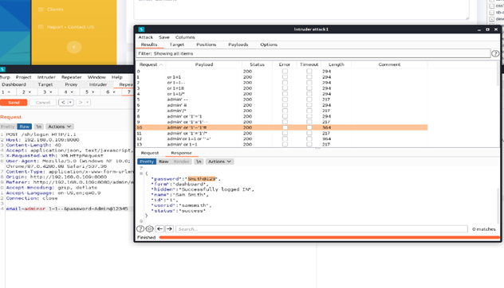

**Recommendation**:

|  |
| --- |
| Employ a layered approach to security that includes utilizing parameterized queries when accepting user input, ensuring that only expected data (white listing) is accepted by an application, and harden the database server to prevent data from being accessed inappropriately. |

**5 . Vulnerability Name**:Improper access control

**CWE** : CWE-284

**OWASP Category**:A01:2021 – Broken Access Control

**Description**:The SQL Injection occurs when user-controllable input is interpreted as a SQL command, rather than as normal data, by the backend database.Exploitation of this vulnerability can have critical implications, including creation, modification, or exfiltration of database content.

**Business Impact**:It may be possible to read sensitive information, it is also possible to make changes or even delete this information with a SQL injection attack.

**Vulnerability Path** :<http://192.168.0.109:8080/>

**Vulnerability Parameter**:<http://192.168.0.109:8080/admin/en/vulnerability>

**Steps to Reproduce** :

Step 1. Access the URL



Step 2:- Try to enter the login credentials



Step 3 :- After that with the default credentials assessed we can gain access to the database with entering the default credentials.

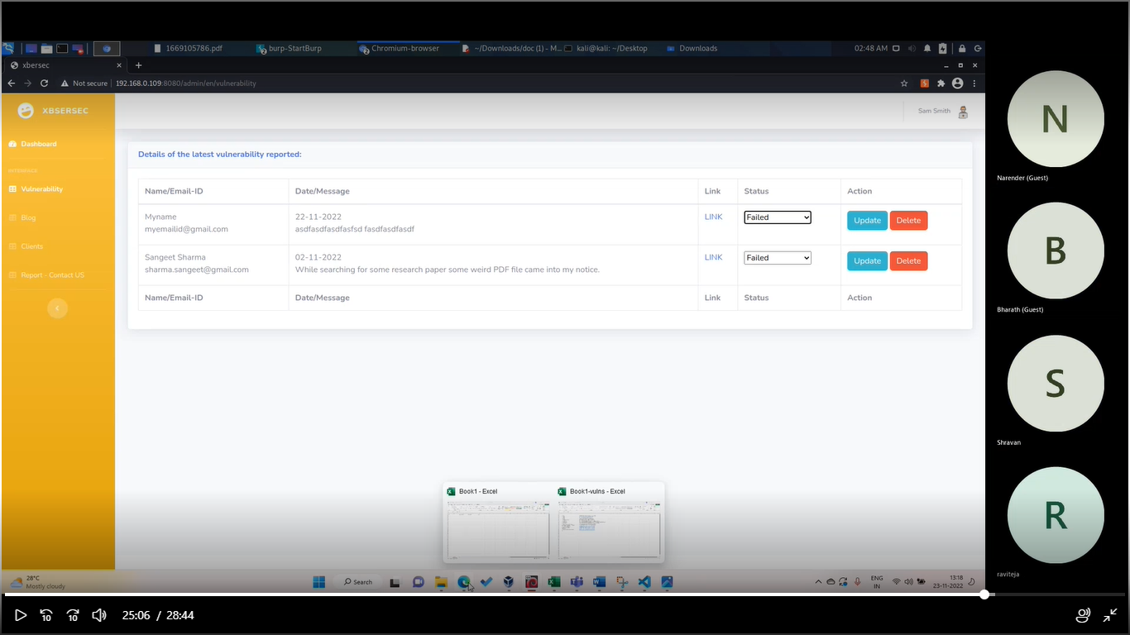

Step 4:- this is the map where status url remain unchanged ➖

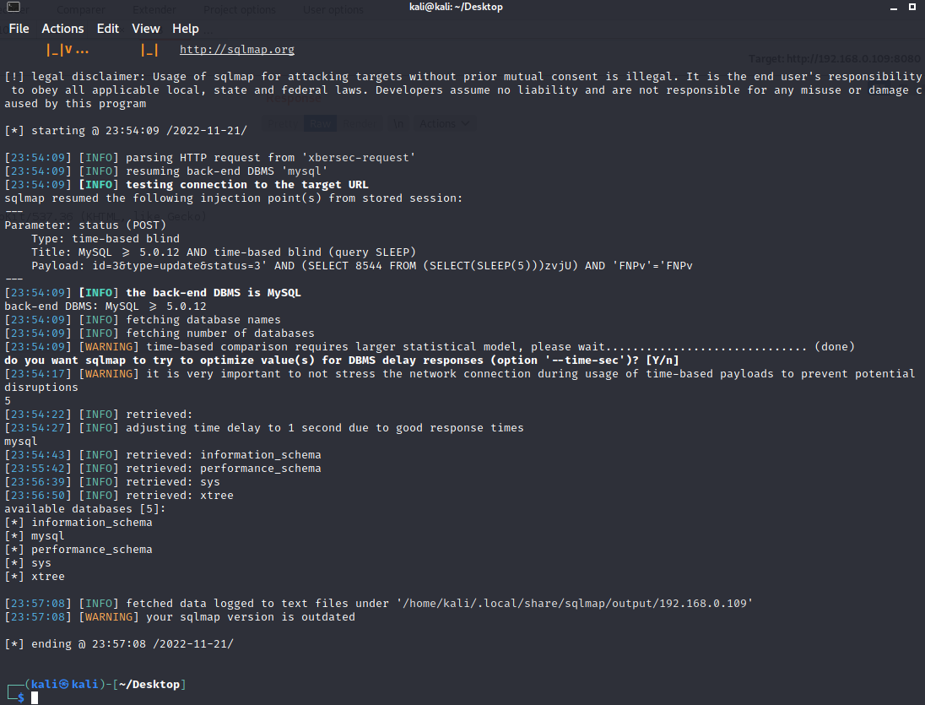

**Recommendation**:

* Applications should not incorporate any user-controllable data directly into SQL queries.
* Parameterized queries (also known as prepared statements) should be used to safely insert data into predefined queries.

**6 . Vulnerability Name**:Default Credentials

**CWE** : CWE-1392

**OWASP Category**:A07:2021-Identification and Authentication Failures

**Description**:It is common practice for products to be designed to use default keys, passwords, or other mechanisms for authentication. The rationale is to simplify the manufacturing process or the system administrator's task of installation and deployment into an enterprise. However, if admins do not change the defaults, it is easier for attackers to bypass authentication quickly across multiple organizations.

**Business Impact**:Attackers can easily obtain default passwords and identify internet-connected target systems. Passwords can be found in product documentation and compiled lists available on the internet.

**Vulnerability Path** :<http://192.168.0.109:8080/>

**Vulnerability Parameter**:<http://192.168.0.109:8080/manager/html>

**Steps to Reproduce** :Step 1. Access the URL

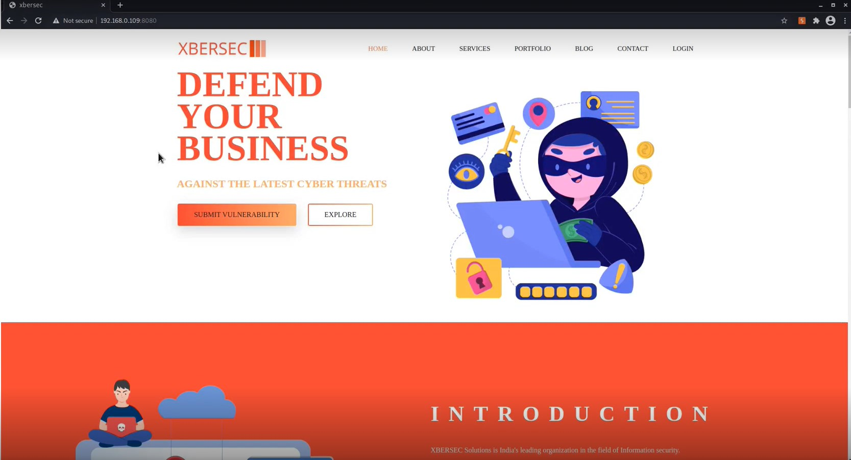

Step 2: By changing the URL parameters with tomcat configurations we find the below page.

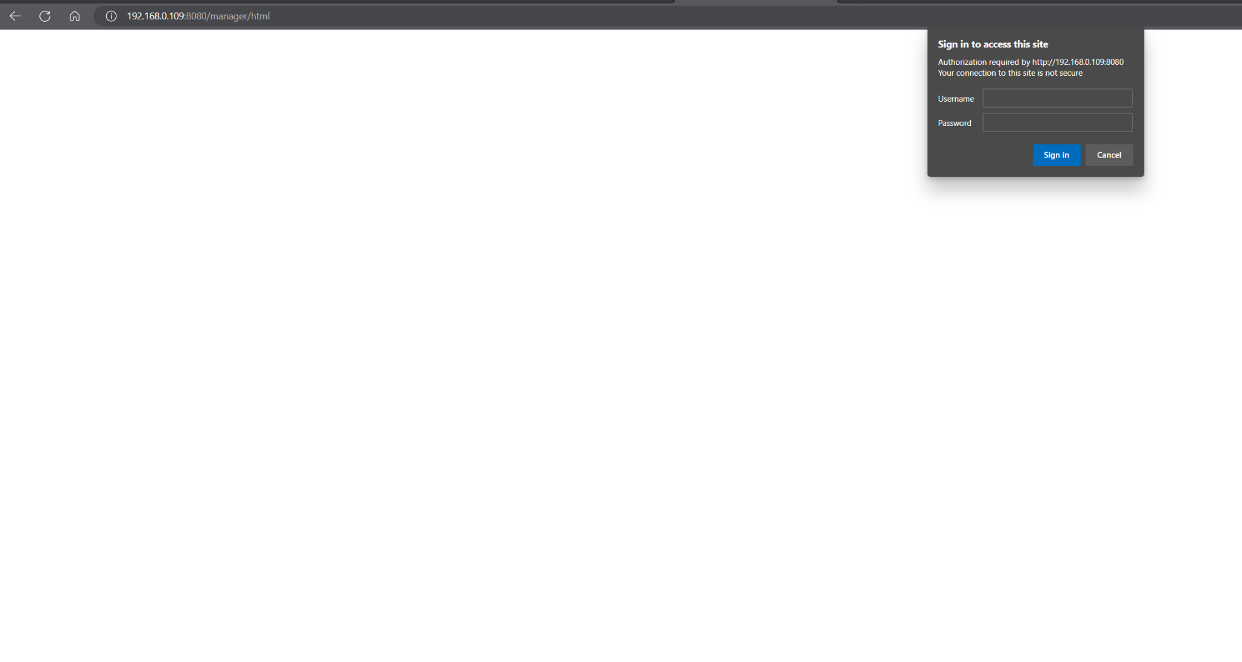

Step 3:- By closing the dialog box without canceling it this will give you the access to

the default credentials

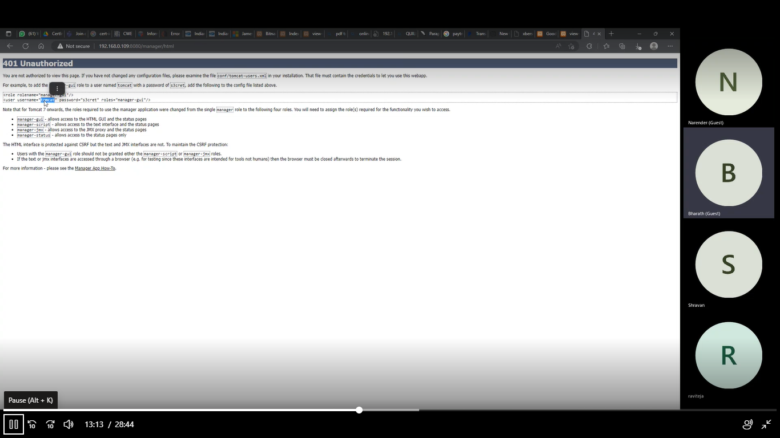

Step4 :- Here in this step the default credentials are printed on the screen which helps to gain access to the DB.

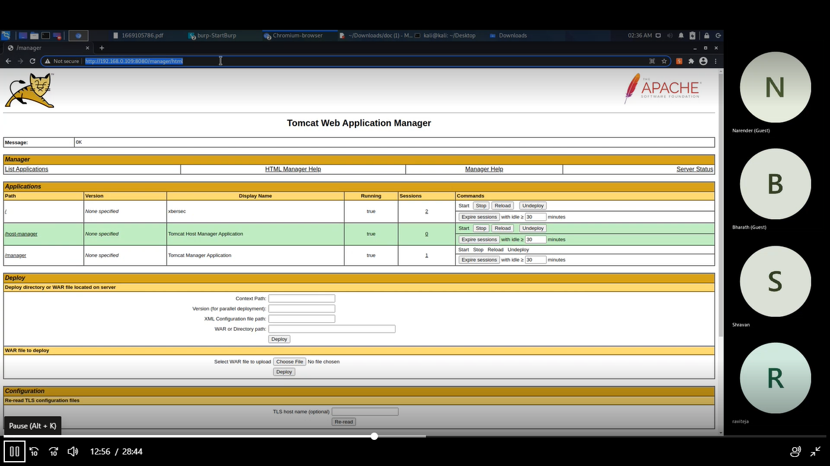

**Recommendation**:

* Prohibit use of default, hard-coded, or other values that do not vary for each installation of the product - especially for separate organizations.

**7—7.1. Vulnerability Name**:File Upload

**CWE** : CWE-434

**OWASP Category**:A03:2021 – Injections

**Description**:The software allows the attacker to upload or transfer files of dangerous types that can be automatically processed within the product's environment.

**Business Impact**:It includes complete system takeover, an overloaded file system or database, forwarding attacks to back-end systems, client-side attacks, or simple defacement. It depends on what the application does with the uploaded file and especially where it is stored.

**Vulnerability Path** :<http://192.168.0.109:8080/>

**Vulnerability Parameter**:1 :-<http://192.168.0.109:8080/tl/vulnerability>

2 :-<http://192.168.0.109:8080/uploads/shell.jsp?cmd=ls>

**Steps to Reproduce** :

Step 1. Access the URL



Step2:- here it gives the access to upload unwanted malicious files which does not restrict .

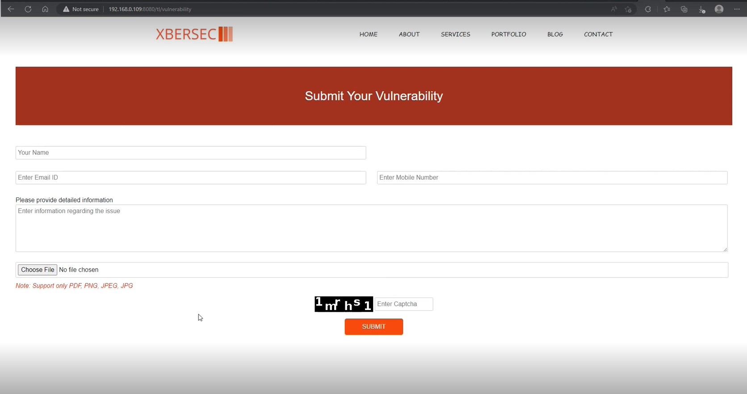

Step3: this how you upload the file parameters in the URL and get the configrations as shown below:-

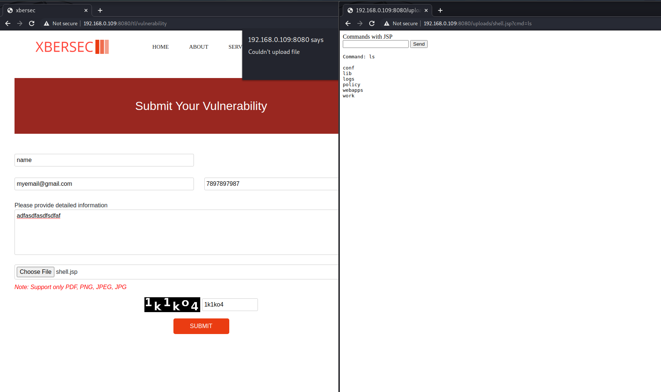

**Recommendation**:

⦁ Segregate Your Uploads.

⦁ Ensure Upload Files Cannot Be Executed.

⦁ Validate File Formats and Extensions.

**7–7 . 2 Vulnerability Name**:File Upload

**CWE** : CWE-434

**OWASP Category**:A03:2021 – Injections

**Description**:The software allows the attacker to upload or transfer files of dangerous types that can be automatically processed within the product's environment.

**Business Impact**:It includes complete system takeover, an overloaded file system or database, forwarding attacks to back-end systems, client-side attacks, or simple defacement. It depends on what the application does with the uploaded file and especially where it is stored.

**Vulnerability Path** :<http://192.168.0.109:8080/>

**Vulnerability Parameter**:1 :-[http://192.168.0.109:8080/admin/en/clients](http://192.168.0.109:8080/tl/vulnerability)

**Steps to Reproduce** :

Step 1. Access the URL



Step2:- here it gives the access to upload unwanted malicious files which does not restrict inside the admin panel .

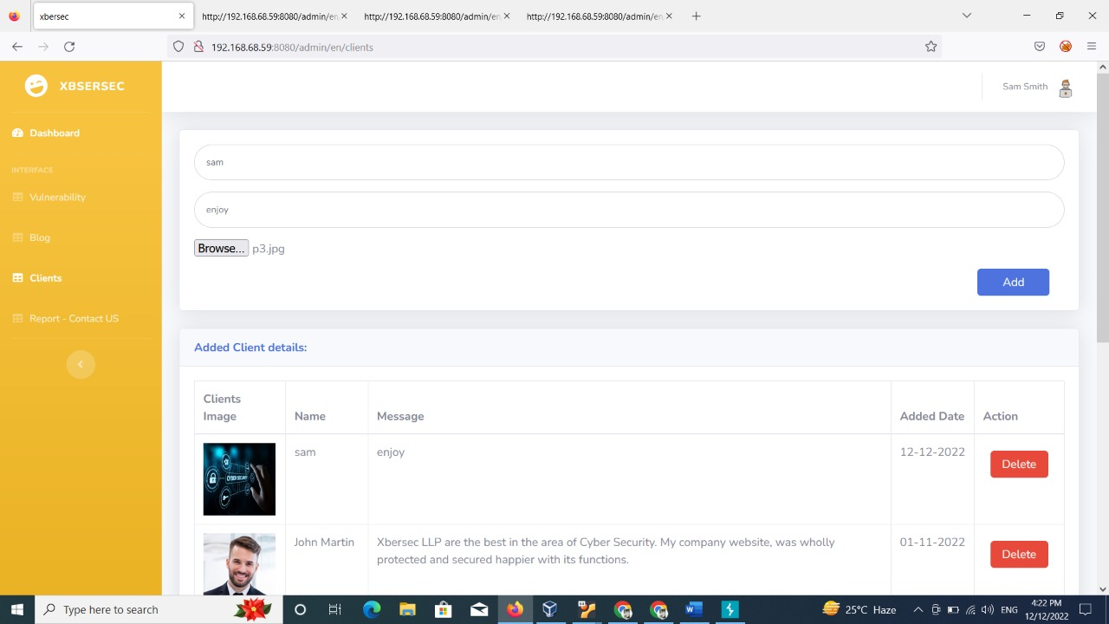

Step3: this how you upload the file parameters in the URL and get the configurations as shown below:-

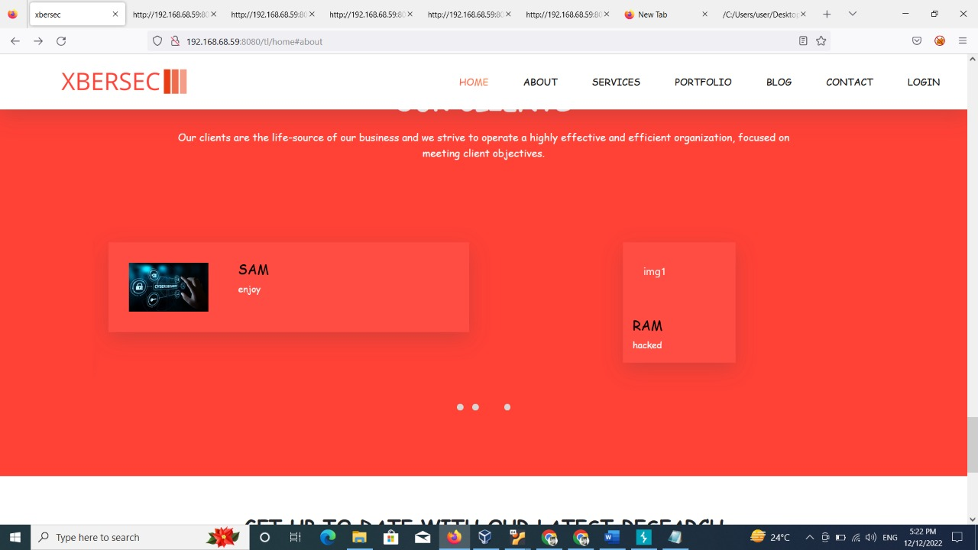

**Recommendation**:

⦁ Segregate Your Uploads.

⦁ Ensure Upload Files Cannot Be Executed.

⦁ Validate File Formats and Extensions.

**7–7 . 3 Vulnerability Name**:SQL injection

**CWE** : CWE-564

**OWASP Category**:A03:2021 – Injections

**Description**:The software allows the attacker to upload or transfer files of dangerous types that can be automatically processed within the product's environment.

**Business Impact**:It includes complete system takeover, an overloaded file system or database, forwarding attacks to back-end systems, client-side attacks, or simple defacement. It depends on what the application does with the uploaded file and especially where it is stored.

**Vulnerability Path** :<http://192.168.0.109:8080/>

**Vulnerability Parameter**:1 :[-http://192.168.0.109:8080/admin/en/profile_settings](http://192.168.0.109:8080/tl/vulnerability)

**Steps to Reproduce** :

Step 1. Access the URL



Step2:- here it gives the access to upload unwanted malicious files which does not restrict

inside the admin panel .

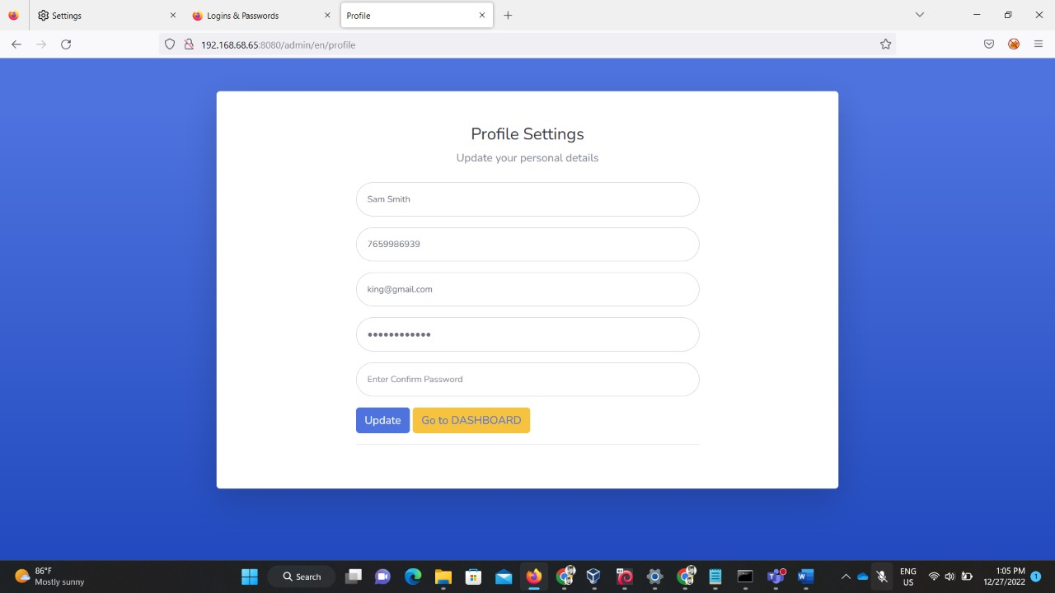

Step3: this how you upload the file parameters in the URL and get the configurations as

shown below:-

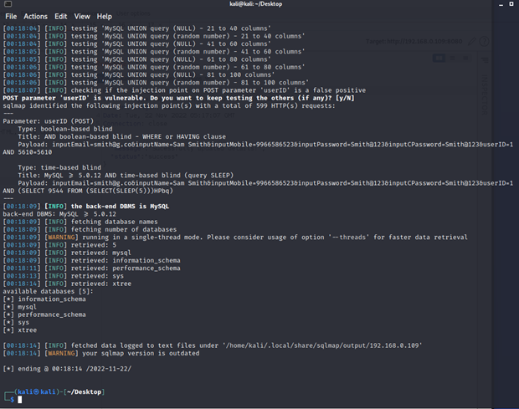

**Recommendation**:

⦁ Segregate Your Uploads.

⦁ Ensure Upload Files Cannot Be Executed.

⦁ Validate File Formats and Extensions.

**8 . Vulnerability Name**:Anti-CSRF Token missing

**CWE** : CWE-352

**OWASP Category**:A05:2021 – Security Misconfiguration

**Description**:The web application does not, or cannot, sufficiently verify whether a well-formed, valid, consistent request was intentionally provided by the user who submitted the request.

**Business Impact**:It can result in damaged client relationships, unauthorized fund transfers, changed passwords and data theft—including stolen session cookies.

**Vulnerability Path** :<http://192.168.0.109:8080/>

**Vulnerability Parameter**:<http://192.168.0.109:8080/>

**Steps to Reproduce** :

Step 1. Access the URL



Step 2: Now intercept with the burp proxy and send request in the repeater

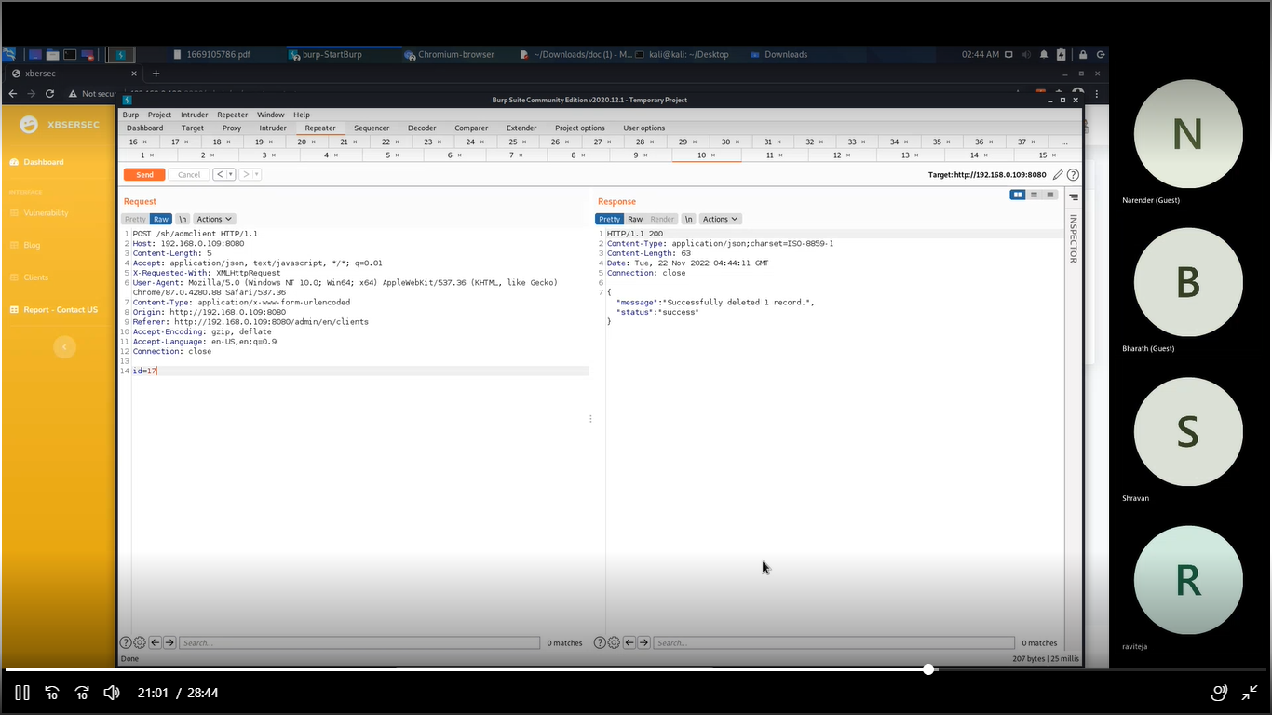

**Recommendation**:

• The most effective way to protect against CSRF vulnerabilities is to include within relevant requests an additional token that is not transmitted in a cookie.

• validate that Host and Refer headers in relevant requests are both present and contain the same domain name

**9 . Vulnerability Name**: Apache Tomcat Enabled

**CWE** : 284

**OWASP Category**: A02:2021 – Cryptographic Failures

**Description**:The product exposes sensitive information to an actor that is not explicitly authorized to have access to that information

**Business Impact**: Security incident leads to the accidental or unlawful destruction, loss, alteration, or unauthorized disclosure of, or access to sensitive data. Such Data exposure may occur as a result of inadequate protection of a database, misconfigurations when bringing up new instances of datastores, inappropriate usage of data systems, and more

**Vulnerability Path** :<http://192.168.0.109:8080/>

**Vulnerability Parameter**:[http://192.168.0.109:8080/manager](http://192.168.0.109:8080/manager/html)

**Steps to Reproduce** :

Step 1. Access the URL



Step 2: change the url parameter by tomcat server manager then we will cancel it as shown in the below page.

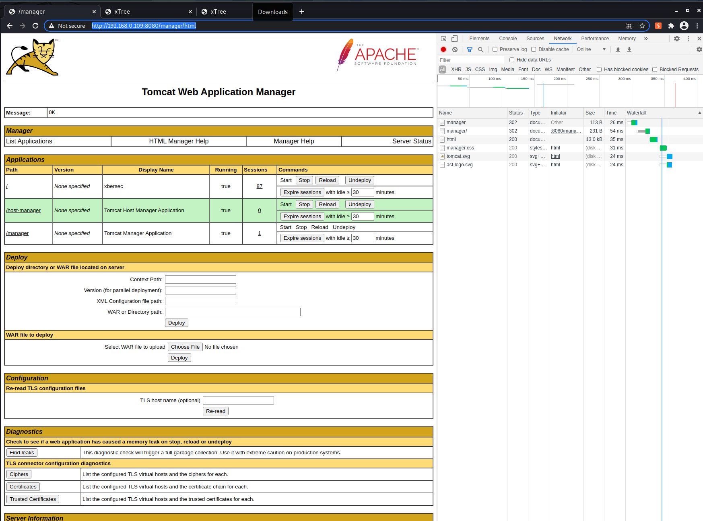

**Recommendation**:

* Organizations must have appropriate security controls in place to avoid the occurrence of sensitive data exposures as well as to limit their impacts on data subjects

**10. Vulnerability Name: System Information Exposure**

**CWE** : CWE-497

**OWASP Category**: A05:2021 – Security Misconfiguration

**Description**:The application does not properly prevent sensitive system-level information from being accessed by unauthorized actors who do not have the same level of access to the underlying system as the application does.

**Business Impact**: This may lead to expose of admin interfaces and allow the adversary to get privileged access, configuration details or business logic, and even add, remove, or modify application functionality

**Vulnerability Path** :<http://192.168.0.109:8080/>

**Vulnerability Parameter**:[http://192.168.0.109:8080](http://192.168.0.109:8080/)/

**Steps to Reproduce** :

Step 1. Access the URL



Step 2:- here we see that the modification of the data in the profile is possible and it also successful in this.

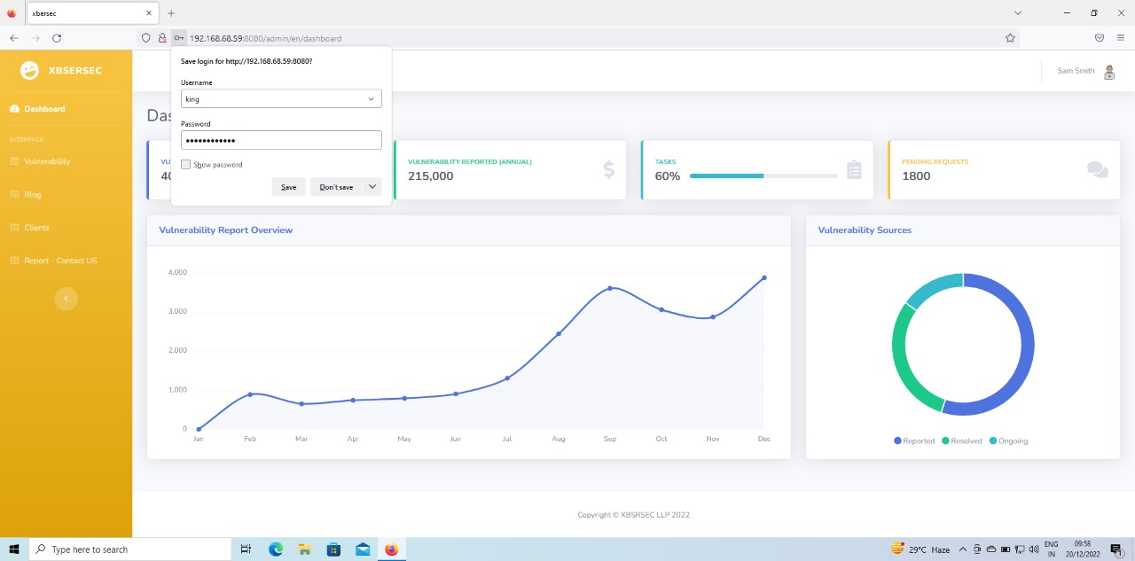

**Recommendation**:

⦁ Use a Segmented App Architecture

⦁ Keep the Platform Clean

⦁ Disable Directory Listing & Verify Directories’ Permissions

**11 . Vulnerability Name: Secure Http flag**

**CWE** : CWE-497

**OWASP Category**: A05:2021 – Security Misconfiguration

**Description**:The software uses a cookie to store sensitive information, but the cookie is not marked with the HttpOnly flag.

**Business Impact**: This measure makes certain client-side attacks, such as cross-site scripting, slightly harder to exploit by preventing them from trivially capturing the cookie's value via an injected script.

**Vulnerability Path** :<http://192.168.0.109:8080/>

**Vulnerability Parameter**:<http://192.168.0.109:8080/>

**Steps to Reproduce** :

Step 1. Access the URL



Step 2: Now intercept with burp proxy and run the request in the repeater.

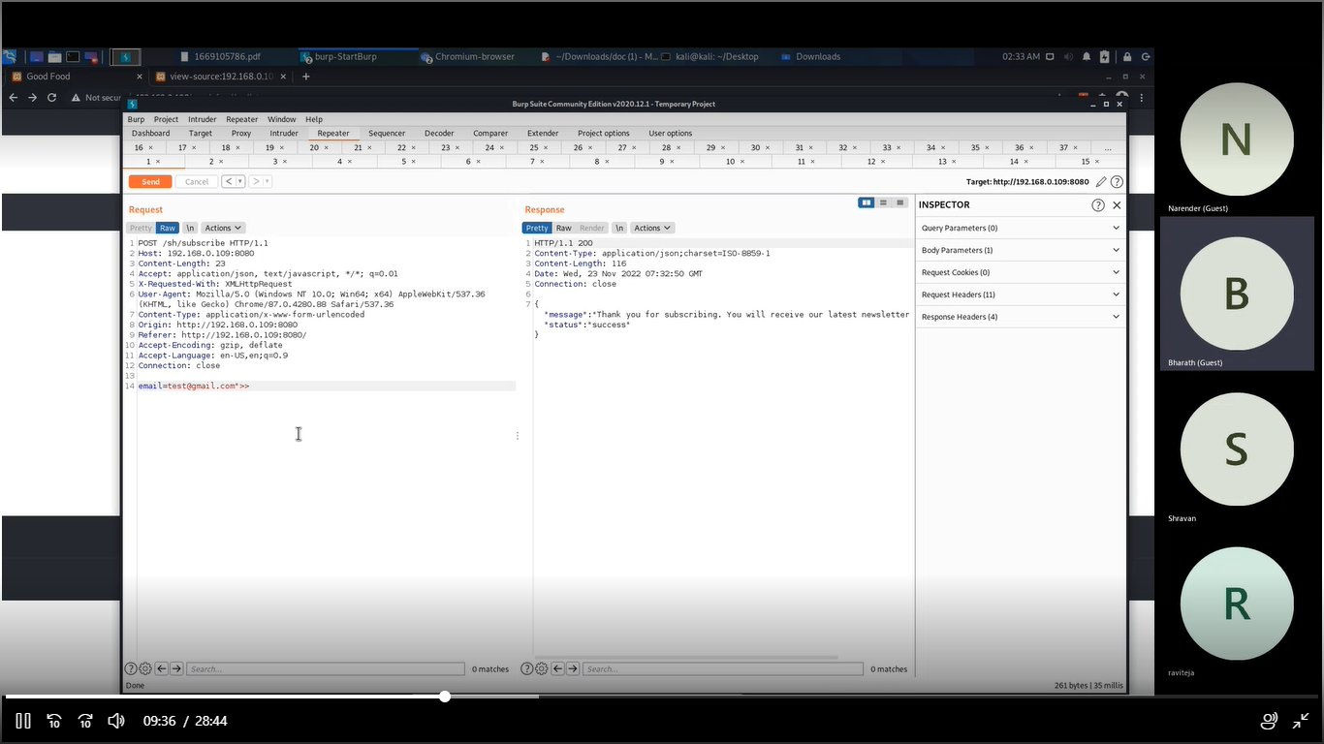

**Recommendation**:

* You specifically require legitimate client-side scripts within your application to read or set a cookie's value, you should set the HttpOnly flag by including this attribute within the relevant Set-cookie directive

**12 . Vulnerability Name: SSL Encryption is not enabled**

**CWE** : 319

**OWASP Category**: A05:2021 – Security Misconfiguration

**Description**:: User credentials are transmitted over an unencrypted channel. This information should always be transferred via an encrypted channel(HTTPS) to avoid being intercepted by a malicious user.

**Business Impact** : In the absence of an SSL certificate, all your communications are not encrypted at all. Meaning attackers have access to all the data. This includes simple login or registration details, feedback data to most important credit card details as well

**Vulnerability Path** :<http://192.168.0.109:8080/>

**Vulnerability Parameter**:<http://192.168.0.109:8080/>

**Steps to Reproduce** :

Step 1. Access the URL



Step2:On the address bar type the following link <http://192.168.0.109/8080/>

Notice that for both admin link and normal user link communication is done through unsecured

protocol(HTTP).

**Recommendation**:

* User credentials are considered as sensitive information, should always be transmitted through to the server over a secured channel(HTTPS)

**13 . Vulnerability Name: Local file Inclusion**

**CWE** : 98

**OWASP Category:** A05:2021 – Security Misconfiguration

**Description:** Local File Inclusion is an attack technique in which attackers trick a web application into either running or exposing files on a web server. LFI attacks can expose sensitive information, and in severe cases, they can lead to cross-site scripting (XSS) and remote code execution

**Business Impact** :A local file inclusion vulnerability can lead to Directory Traversal attacks, where an attacker will try to find and access files on the web server to gain more useful information, such as log files. Log files can reveal the structure of the application or expose paths to sensitive files.

**Vulnerability Path** : <http://192.168.0.109:8080/>

**Vulnerability Parameter**:<http://192.168.0.109:8080/>

**Steps to Reproduce** :

Step 1: Access to the url

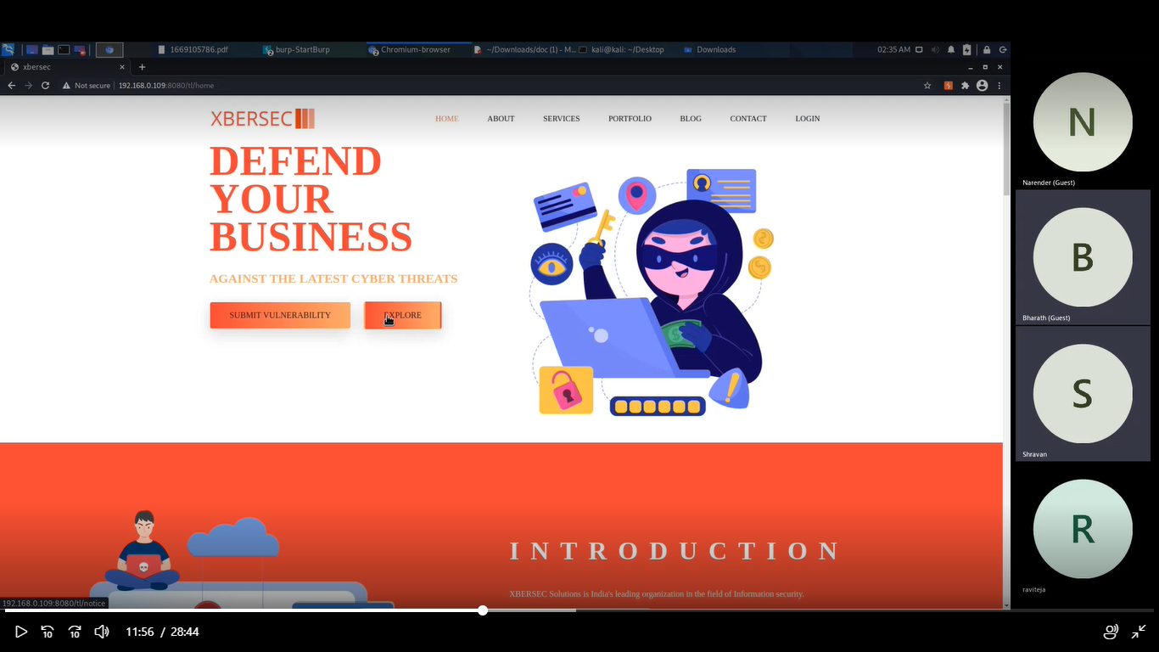

Step2: Click on the blog we will get whitepapers title page

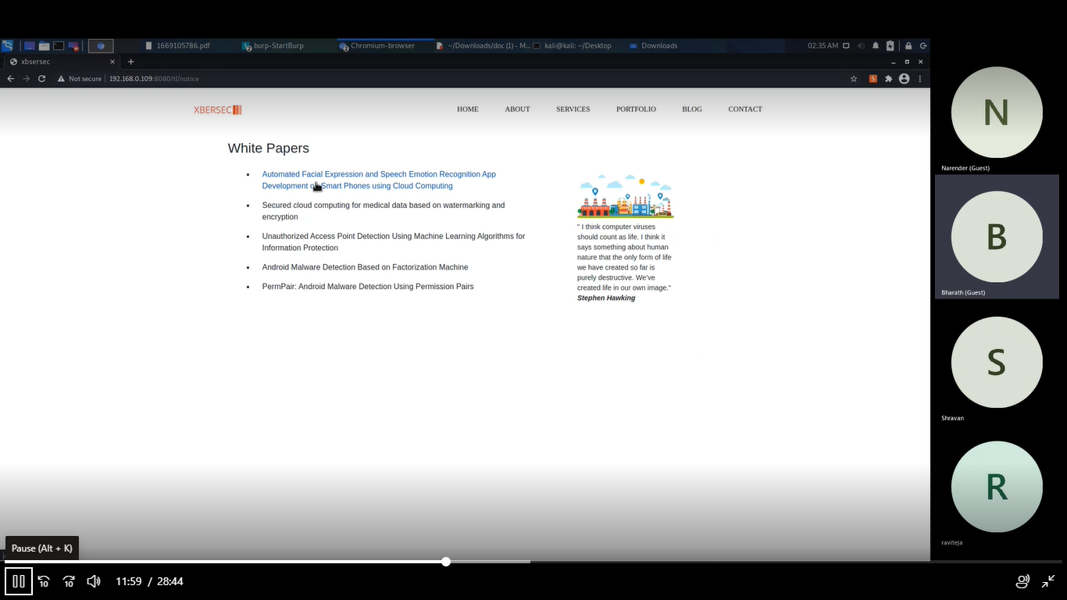

Step 3: click on link we will be redirected to the pdf

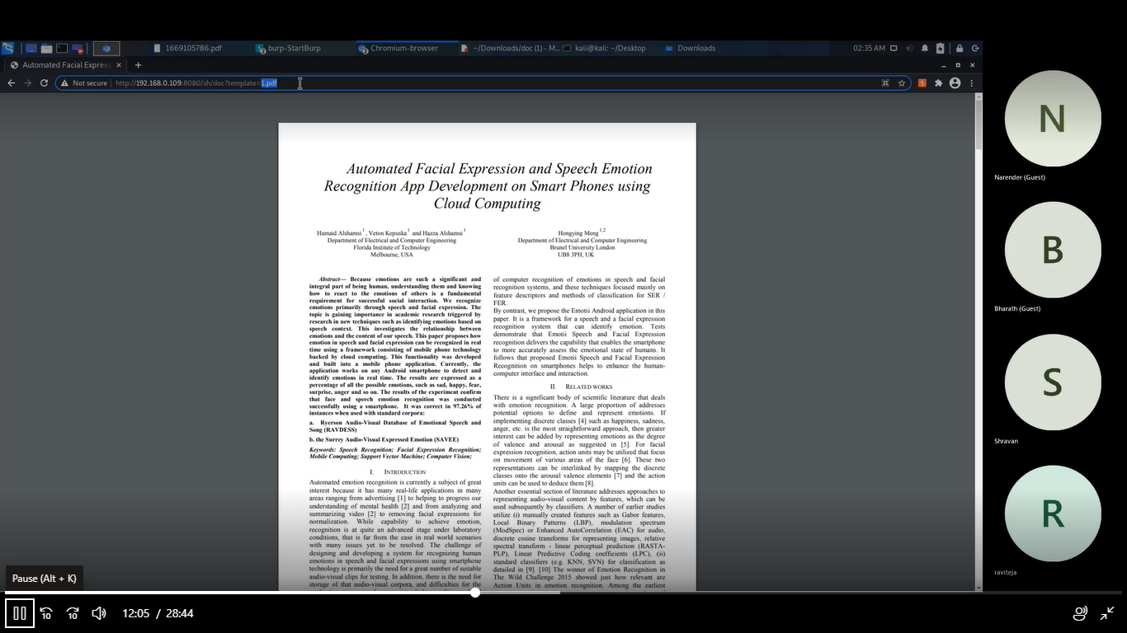

Step4 : By tampering with the url we get the files.

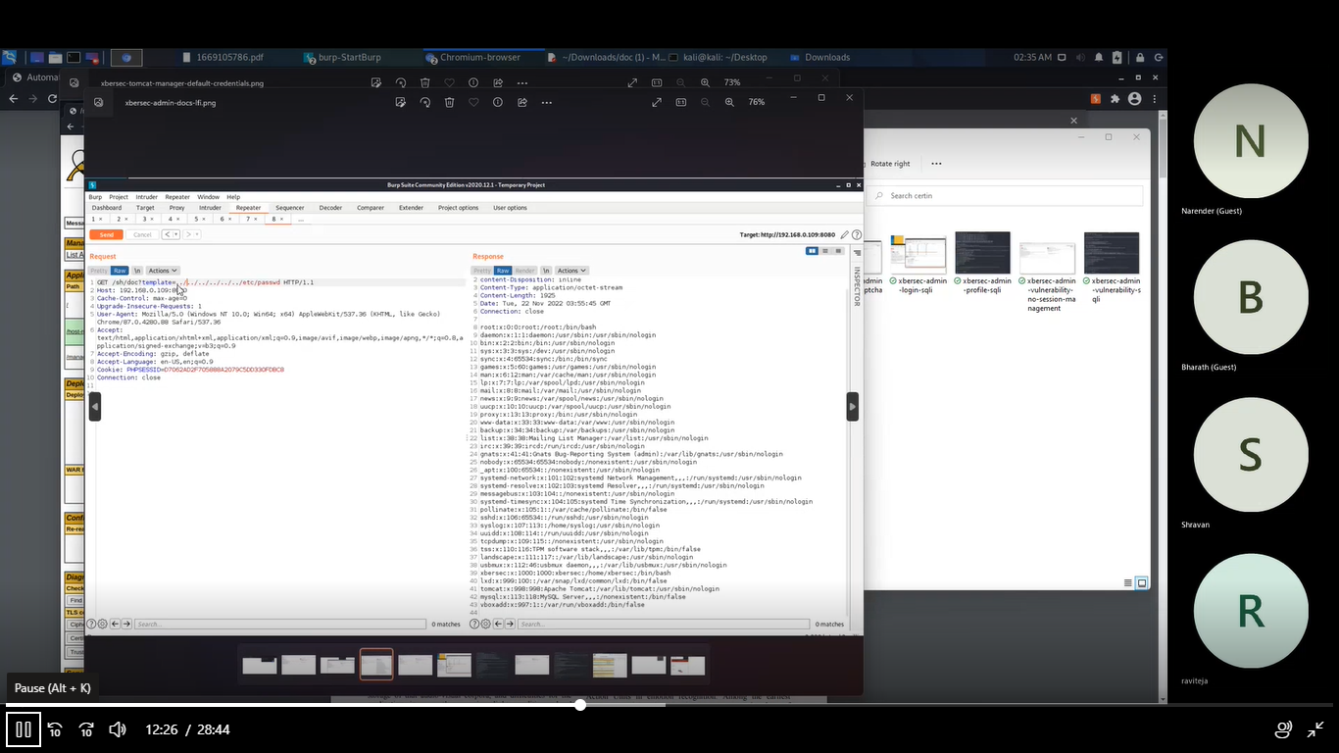

**Recommendation**:

Don't include files on a web server that can be compromised, use a database instead. Better server instructions – make the server send download headers automatically instead of executing files in a specified directory

**14–14.1 .Vulnerability Name**: Cross-Site Scripting (Reflected)

**CWE** : CWE-79

**OWASP Category: A03:2021 –Injections**

**Description**: It occurs when a malicious script is reflected off of a web application to the victim's browser. The script is activated through a link, which sends a request to a website with a vulnerability that enables

execution of malicious scripts.

**Business Impact:** The server reads data directly from the HTTP request and reflects it back in the HTTP response. Reflected XSS exploits occur when an attacker causes a victim to supply dangerous content to a vulnerable web application, which is then reflected back to the victim and executed by the web browser. The most common mechanism for delivering malicious content is to include it as a parameter in a URL that is posted publicly or e-mailed directly to the victim.

**Vulnerability Path :**  <http://192.168.0.109:8080/>

**Vulnerability Parameter**: <http://192.168.0.109:8080/admin/en/blog>

**Steps to Reproduce** :

**Step 1.** Access the URL



Step2: After clicking on the blog site we will get a pop which is vulnerable to cross site scripting.

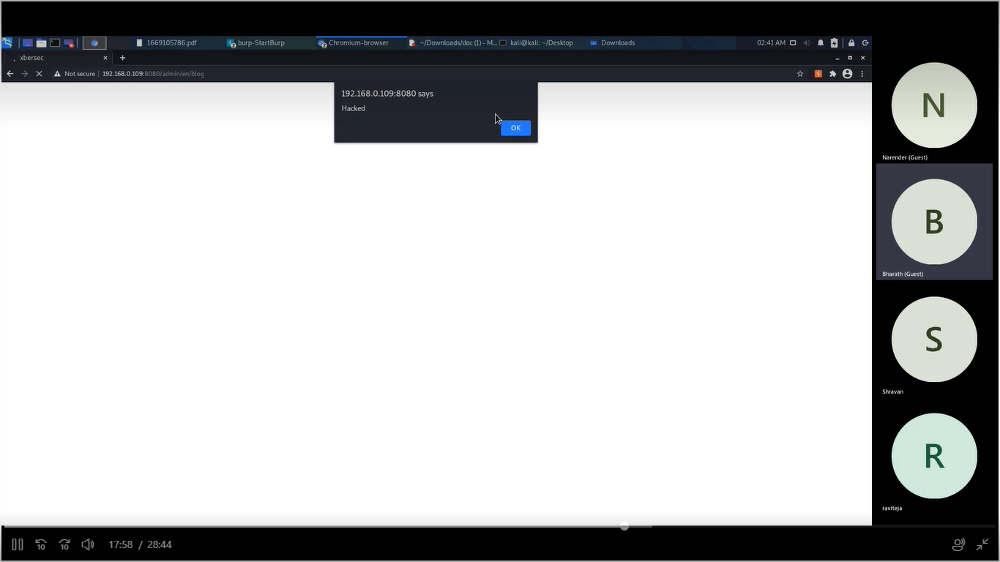

**Recommendation:**

⦁ Validate user input

⦁ Escape dynamic content

⦁ Implement a content security policy

**14–14.2 .Vulnerability Name**: Cross-Site Scripting (Reflected)

**CWE** : CWE-79

**OWASP Category: A03:2021 –Injections**

**Description**: It occurs when a malicious script is reflected off of a web application to the victim's browser. The script is activated through a link, which sends a request to a website with a vulnerability that enables

execution of malicious scripts.

**Business Impact:** The server reads data directly from the HTTP request and reflects it back in the HTTP response. Reflected XSS exploits occur when an attacker causes a victim to supply dangerous content to a vulnerable web application, which is then reflected back to the victim and executed by the web browser. The most common mechanism for delivering malicious content is to include it as a parameter in a URL that is posted publicly or e-mailed directly to the victim.

**Vulnerability Path :**  <http://192.168.0.109:8080/>

**Vulnerability Parameter**: <http://192.168.0.109:8080/admin/en/blog>

**Steps to Reproduce** :

**Step 1.** Access the URL



Step2: After clicking on the blog site we will get a pop which is vulnerable to cross site scripting.

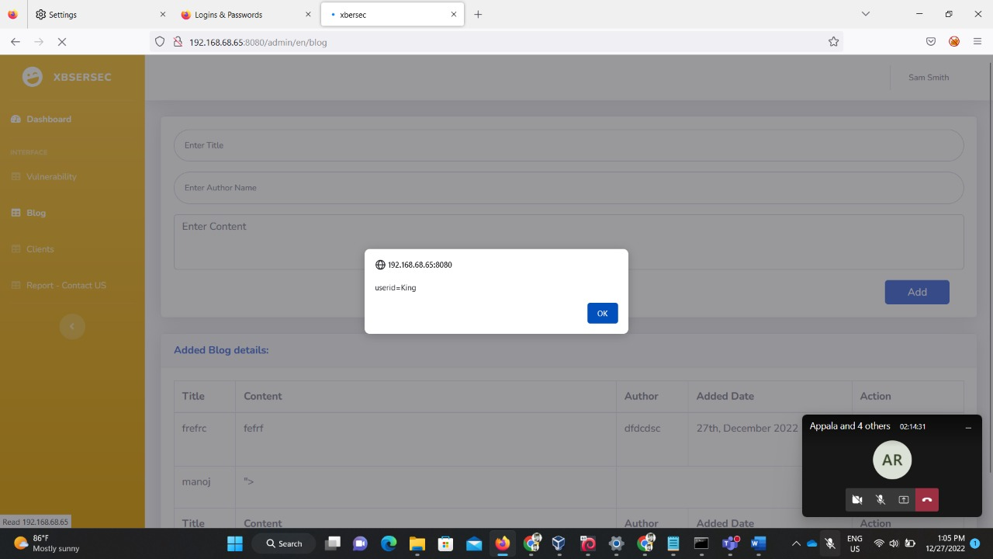

**Recommendation:**

⦁ Validate user input

⦁ Escape dynamic content

⦁ Implement a content security policy

**15.Vulnerability Name**: **: Violation of Secure Design Principles**

**CWE** :CWE-657

**OWASP Category: A04:2021 – Insecure Design**

**Description**: insecure design is a broad category representing different weaknesses, expressed as “missing or ineffective control design.” Insecure design is not the source for all other Top 10 risk categories. There is a difference between insecure design and insecure implementation. We differentiate between design flaws and implementation defects for a reason, they have different root causes and remediation. A secure design can still have implementation defects leading to vulnerabilities that may be exploited. An insecure design cannot be fixed by a perfect implementation as by definition, needed security controls were never created to defend against specific attacks. One of the factors that contribute to insecure design is the lack of business risk profiling inherent in the software or system being developed, and thus the failure to determine what level of security design is required.

**Business Impact:** This mainly focuses on risks related to design and architectural flaws, with a call for more use of threat modeling, secure design patterns, and reference architectures. As a community we need to move beyond "shift-left" in the coding space to pre-code activities that are critical for the principles of Secure by Design. Notable Common Weakness Enumerations (CWEs) include *CWE-209: Generation of Error Message Containing Sensitive Information*,

**Vulnerability Path :** <http://192.168.0.109:8080/>

**Vulnerability Parameter**: <http://192.168.68.59:8080/admin/en/profile>

**Steps to Reproduce** :

**Step 1.** Access the URL (The actual name here is sam smith but here it allows you edit the name )

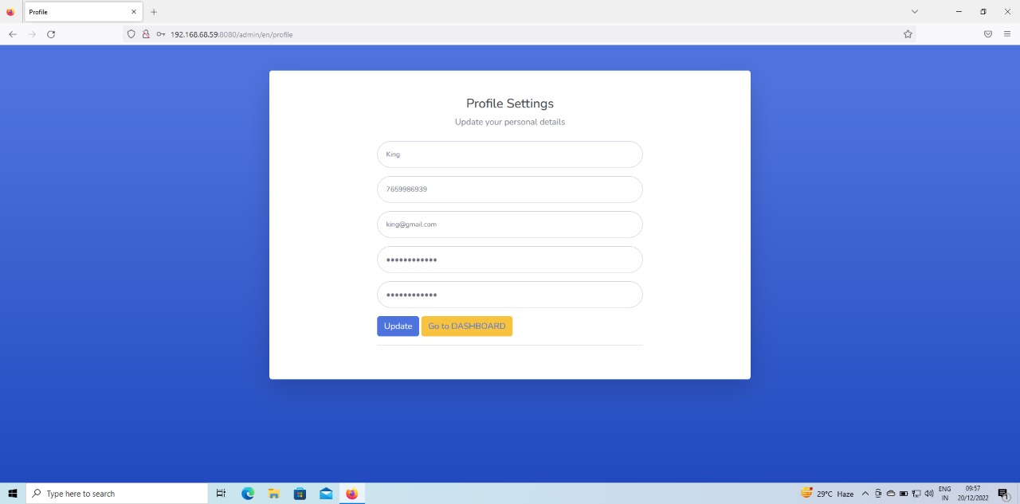

**Step 2:** After this you can save the details in the next step which will successfully store these details .

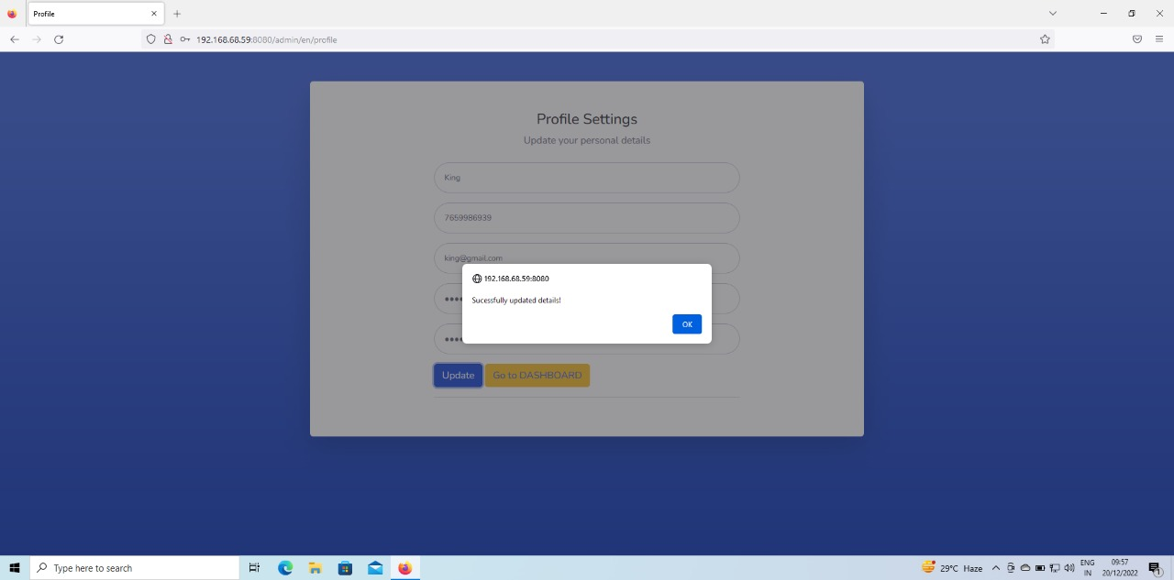

**Step 3 :**Now you can login with an updated name and it allows you with the same old credentials.

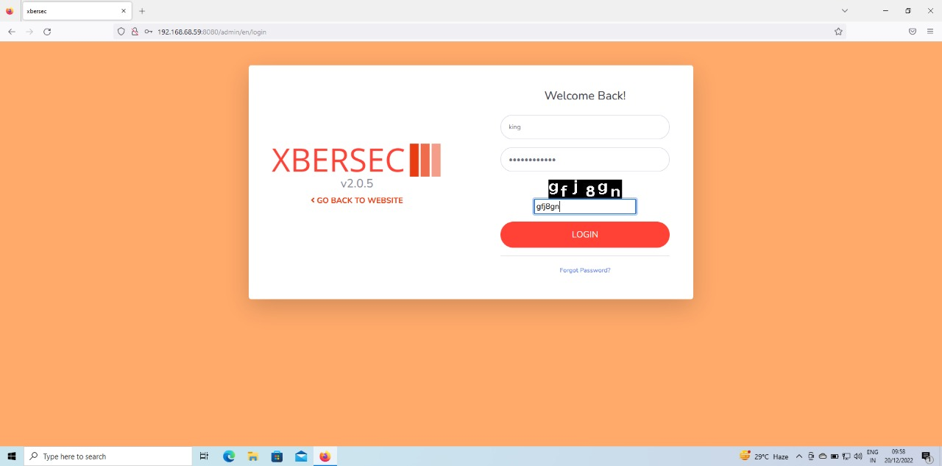

**Step 4 :** As you can see, we updated the name but still it shows the same old name .



**Recommendation:**

* Establish and use a secure development lifecycle with AppSec professionals to help evaluate and design security and privacy-related controls
* Establish and use a library of secure design patterns or paved road ready to use components
* Use threat modeling for critical authentication, access control, business logic, and key flows
* Integrate security language and controls into user stories
* Integrate plausibility checks at each tier of your application (from frontend to backend)
* Write unit and integration tests to validate that all critical flows are resistant to the threat model. Compile use-cases *and* misuse-cases for each tier of your application.

**15–15.2 Vulnerability Name**: Clickjacking (Improper Restriction of Rendered UI Layers or Frames)

**CWE** :CWE-1021

**OWASP Category: A04-2021- insecure design**

**Description**:it occurs whenever a web application is fetching a remote resource without validating the user-supplied URL. It allows an attacker to coerce the application to send a crafted request to an unexpected destination, even when protected by a firewall, VPN, or another type of network access control list (ACL).

**Business Impact:** The data shows a relatively low incidence rate with above average testing coverage and above-average Exploit and Impact potential ratings. As new entries are likely to be a single or small cluster of Common Weakness Enumerations (CWEs) for attention and awareness, the hope is that they are subject to focus and can be rolled into a larger category in a future edition.

**Vulnerability Path :** <http://192.168.0.109:8080/>

**Vulnerability Parameter**: [http://192.168.68.59:8080](http://192.168.68.59:8080/admin/en/profile)

**Steps to Reproduce** :

Step 1:- Access the URl



Step 2:- we write a html code as shown below when we run with the ip address with sight

the we get

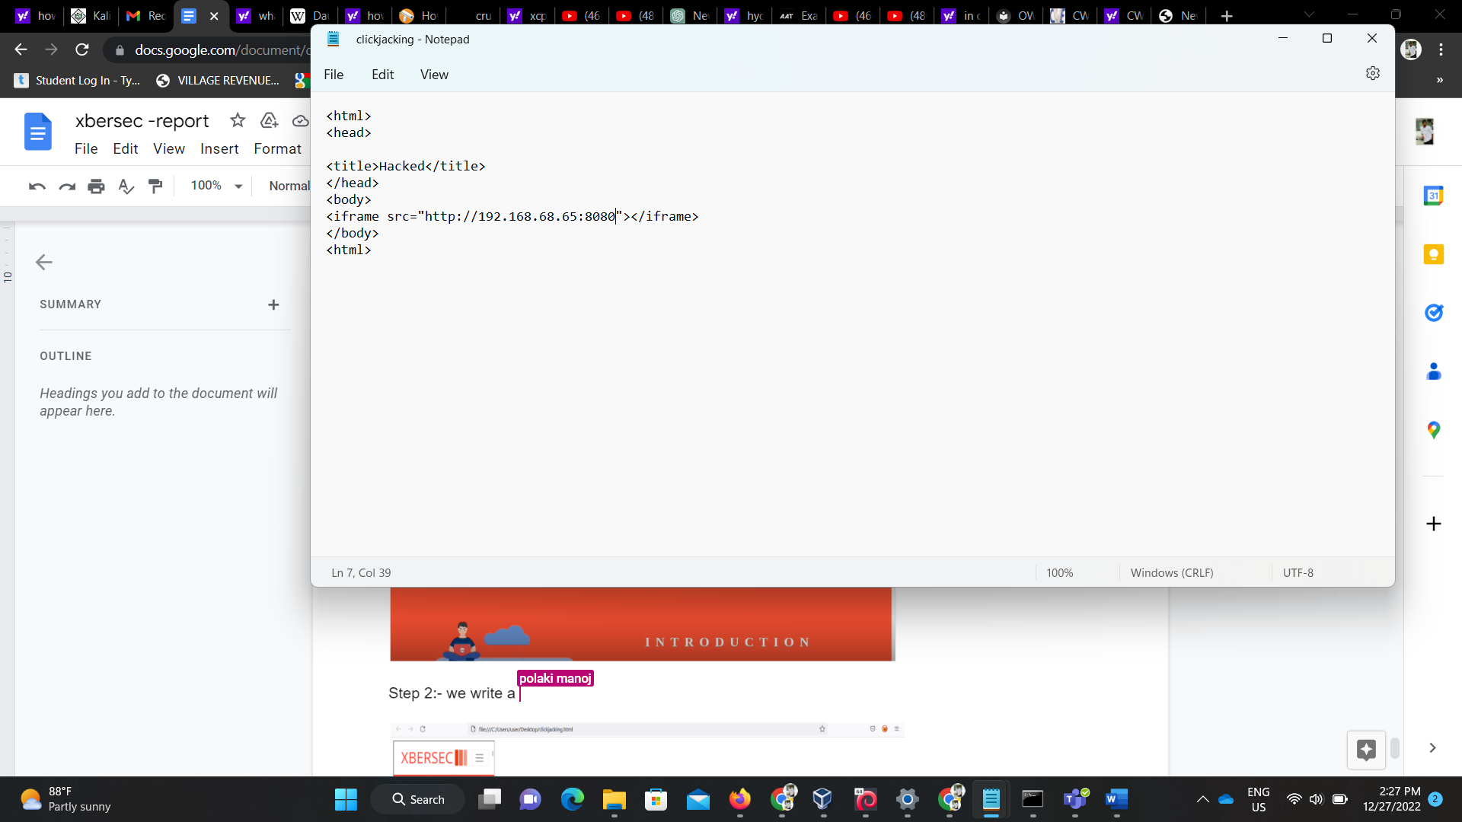

Step 3:- this will be the output of clickjacking the website with html code .

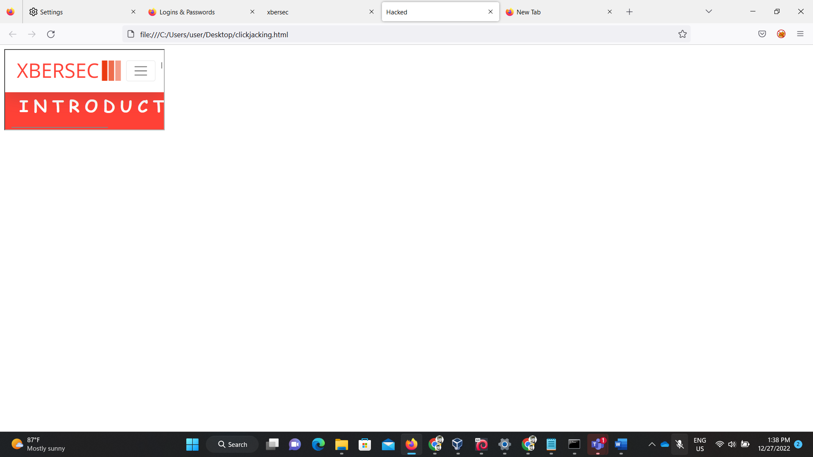

**Recommendation:**

* Segment remote resource access functionality in separate networks to reduce the impact of SSRF
* Enforce “deny by default” firewall policies or network access control rules to block all but essential intranet traffic.
* Enforce the URL schema, port, and destination with a positive allow list
* Do not send raw responses to clients
* Disable HTTP redirections

**16. Vulnerability Name**: **Reliance on Cookies without Validation and Integrity Checking in a Security Decision**

**CWE** :CWE-784:

**OWASP Category:A08:2021 – Software and Data Integrity Failures**

**Description**: Software and data integrity failures relate to code and infrastructure that does not protect against integrity violations. An example of this is where an application relies upon plugins, libraries, or modules from untrusted sources, repositories, and content delivery networks (CDNs). An insecure CI/CD pipeline can introduce the potential for unauthorized access, malicious code, or system compromise. Lastly, many applications now include auto-update functionality, where updates are downloaded without sufficient integrity verification and applied to the previously trusted application. Attackers could potentially upload their own updates to be distributed and run on all installations. Another example is where objects or data are encoded or serialized into a structure that an attacker can see and modify is vulnerable to insecure deserialization.

**Business Impact:** This mainlyfocuses on making assumptions related to software updates, critical data, and CI/CD pipelines without verifying integrity. One of the highest weighted impacts from Common Vulnerability and Exposures/Common Vulnerability Scoring System (CVE/CVSS) data. Notable Common Weakness Enumerations (CWEs) include *CWE-829: Inclusion of Functionality* .

**Vulnerability Path :** <http://192.168.0.109:8080/>

**Vulnerability Parameter**: [http://192.168.0.109:8080/admin/en/blog](http://192.168.0.109:8080/)

**Steps to Reproduce** : **Step 1.** Access the URL



**Step 2 :**Now you can login with an update credentials and session id would be the same .



Step 3:- your session id should not give leakage to any information but here it shows the recently

updated name last login .

**Recommendation:**

* Use digital signatures or similar mechanisms to verify the software or data is from the expected source and has not been altered.
* Ensure libraries and dependencies, such as npm or Maven, are consuming trusted repositories. If you have a higher risk profile, consider hosting an internal known-good repository that's vetted.
* Ensure that a software supply chain security tool, such as OWASP Dependency Check or OWASP CycloneDX, is used to verify that components do not contain known vulnerabilities
* Ensure that there is a review process for code and configuration changes to minimize the chance that malicious code or configuration could be introduced into your software pipeline.
* Ensure that your CI/CD pipeline has proper segregation, configuration, and access control to ensure the integrity of the code flowing through the build and deploy processes.

**17.Vulnerability Name**: Sensitive Cookie without ‘Httponly’ Flag 1021 - Improper design

**CWE** : CWE -1004

**OWASP Category: A09:2021 – Security Logging and Monitoring Failures**

**Description**: basically this category is to help detect, escalate, and respond to active breaches. Without logging and monitoring, breaches cannot be detected. Insufficient logging, detection, monitoring, and active response occurs any time:

* Logs of applications and APIs are not monitored for suspicious activity.
* Logs are only stored locally.
* Appropriate alerting thresholds and response escalation processes are not in place or effective.
* Penetration testing and scans by dynamic application security testing (DAST) tools (such as OWASP ZAP) do not trigger alerts.

**Business Impact:** Logging and monitoring can be challenging to test, often involving interviews or asking if attacks were detected during a penetration test. There isn't much CVE/CVSS data for this category, but detecting and responding to breaches is critical. Still, it can be very impactful for accountability, visibility, incident alerting, and forensics.

**Vulnerability Path :** <http://192.168.0.109:8080/>

**Vulnerability Parameter**: <http://192.168.0.109:8080/admin/en/blog>

**Steps to Reproduce** :

**Step 1.** Access the URL



**Step 2 :**Now you can login with an update credentials and session id would be the same .



Step 3:- your session id should not give leakage to any information but here it shows the recently

updated name last login .

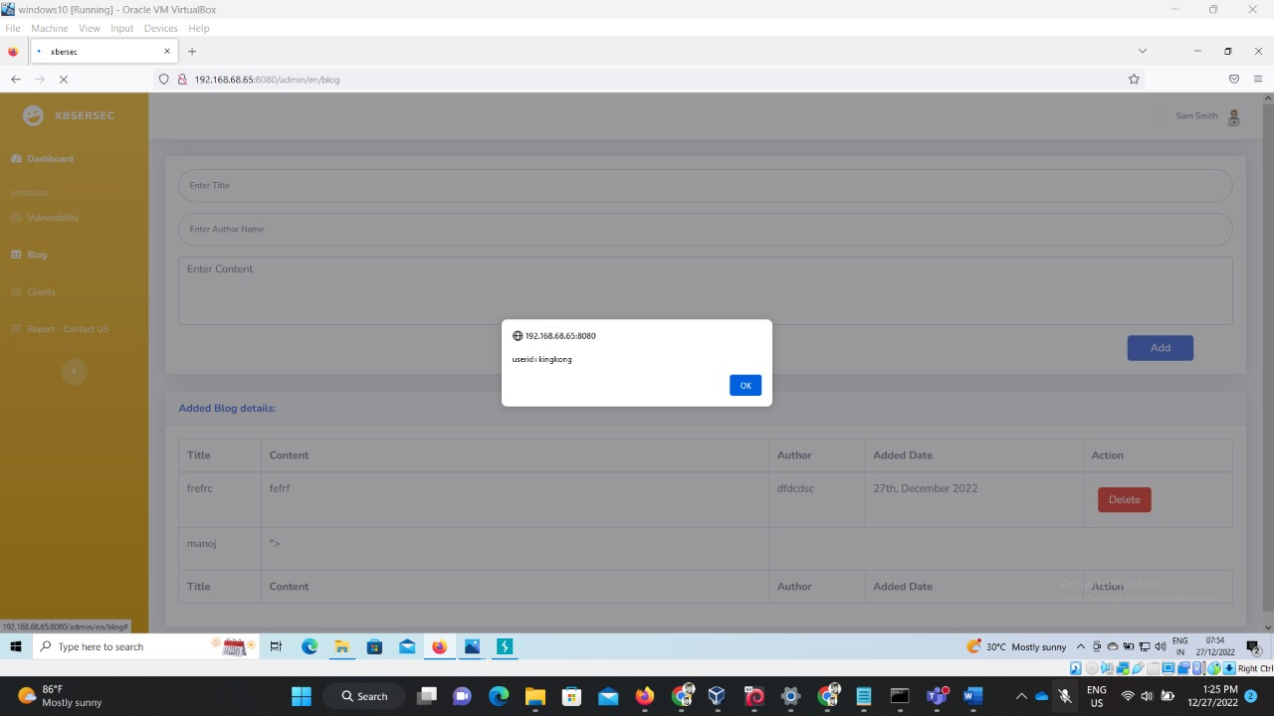

Step 4:- here you can see that both are different browsers having same session ids and same cookies thrown when the cookies are accessed .

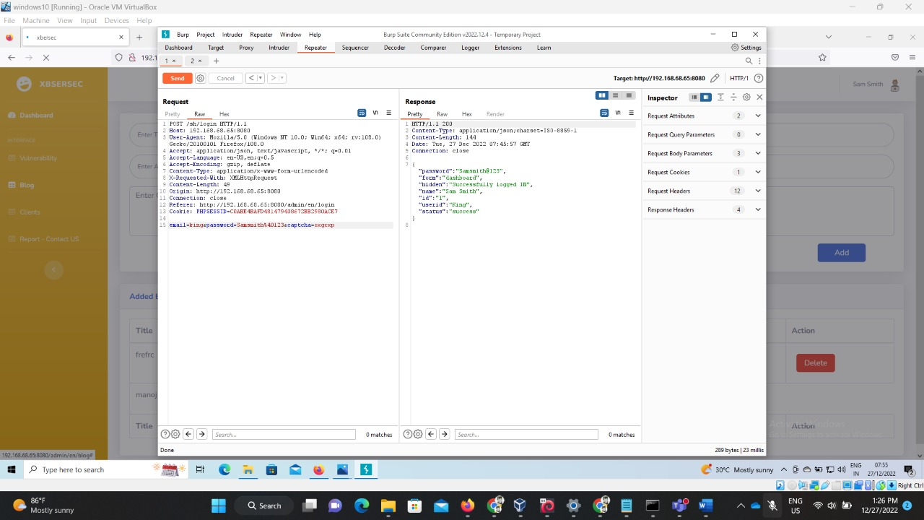

**Recommendation:**

Developers should implement some or all the following controls, depending on the risk of the application:

* Ensure all login, access control, and server-side input validation failures can be logged with sufficient user context to identify suspicious or malicious accounts and held for enough time to allow delayed forensic analysis.
* Ensure that logs are generated in a format that log management solutions can easily consume.
* Ensure log data is encoded correctly to prevent injections or attacks on the logging or monitoring systems.
* Ensure high-value transactions have an audit trail with integrity controls to prevent tampering or deletion, such as append-only database tables or similar.
* DevSecOps teams should establish effective monitoring and alerting such that suspicious activities are detected and responded to quickly.

**18. Vulnerability Name**: **Exposure of Sensitive Information to an Unauthorized Actor**

**CWE** :CWE-200

**OWASP Category: A10:2021-Server-Side Request Forgery (SSRF)**

**Description**:it occurs whenever a web application is fetching a remote resource without validating the user-supplied URL. It allows an attacker to coerce the application to send a crafted request to an unexpected destination, even when protected by a firewall, VPN, or another type of network access control list (ACL).

**Business Impact:** The data shows a relatively low incidence rate with above average testing coverage and above-average Exploit and Impact potential ratings. As new entries are likely to be a single or small cluster of Common Weakness Enumerations (CWEs) for attention and awareness, the hope is that they are subject to focus and can be rolled into a larger category in a future edition.

**Vulnerability Path :** <http://192.168.0.109:8080/>

**Vulnerability Parameter**: [http://192.168.68.59:8080/Manger](http://192.168.68.59:8080/admin/en/profile)

**Steps to Reproduce** :

Step 1:- Access the URl



Step 2: By changing the URL parameters with tomcat configurations we find the below page.



Step 3:- By closing the dialog box without canceling it this will give you the access to

the default credentials



Step4 :- Here in this step the default credentials are printed on the screen which helps to gain access to the internal servers.

**Recommendation:**

* Segment remote resource access functionality in separate networks to reduce the impact of SSRF
* Enforce “deny by default” firewall policies or network access control rules to block all but essential intranet traffic.
* Enforce the URL schema, port, and destination with a positive allow list
* Do not send raw responses to clients
* Disable HTTP redirections